Відповіді на лекцію №11
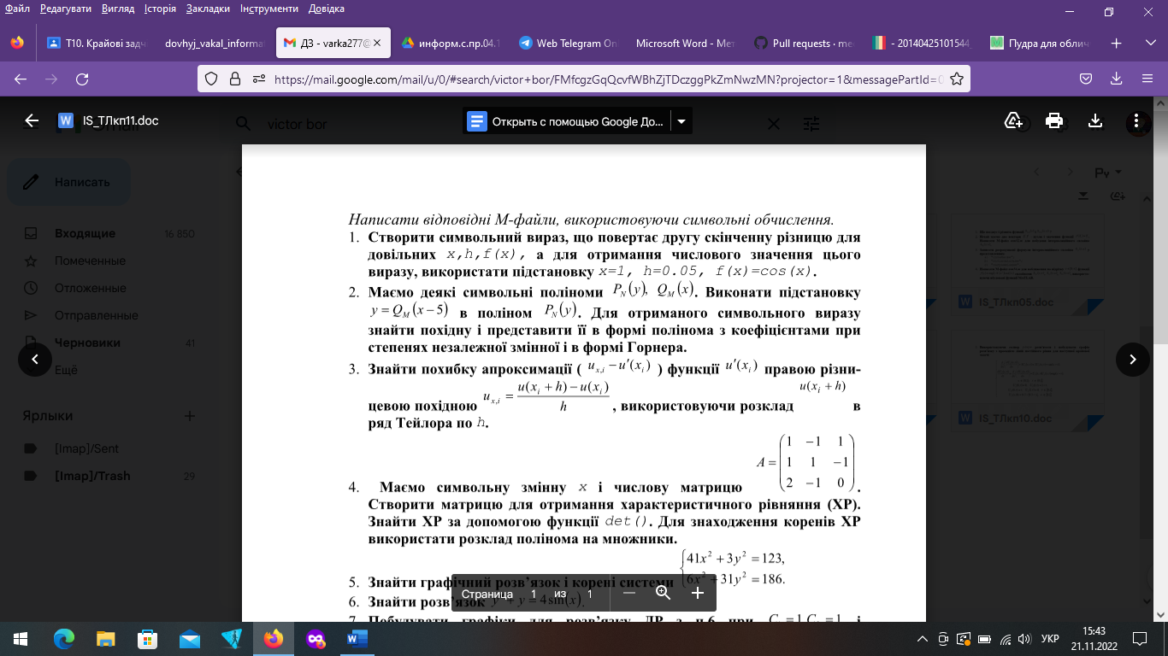
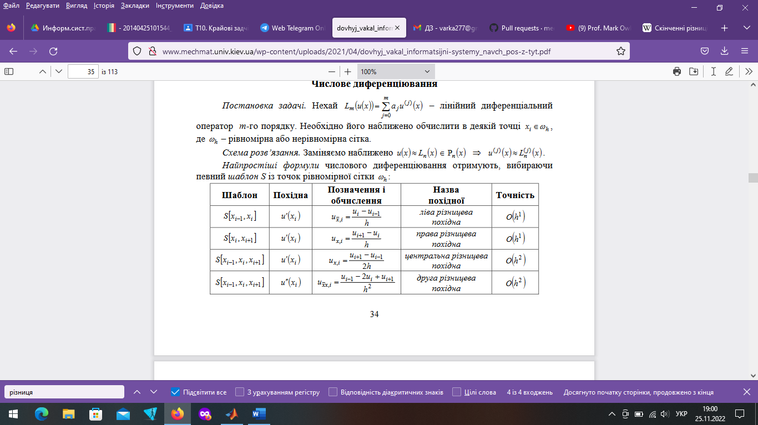
function p_1
clear;
clc;
z = sym('ff(x)')
syms x h;
rdz=(subs(z,x,x-h,x+h)-2*z)/h.2
nh=0.05;nx=1;
ff=@(t)(cos(t));
s=subs(subs(rdz,h,'nh'),x,'nx')
es=vpa(s)
en=eval(s)


clear
clc
syms x y
P(y), Q(x)
s = subs(P,Y,Q*(x-5));
k = diff(s);
V = collect(s,var);
G = horner(s);


%% pl13_5.m
clear; clc
syms x h;
zmh = sym('u(x+h)');
z0h = sym('u(x)');
sm = taylor(zmh, 7, x, h);
Oh = simplify((sm-z0h)/h-diff(z0h,x,2));
Oh = subs(Oh, x, 'Xi'); Oh = collect(Oh);
z = char(Oh); k = findstr(z,'h');
z = z(k(end-1)+3:end);
Oh = simple(sym(z))
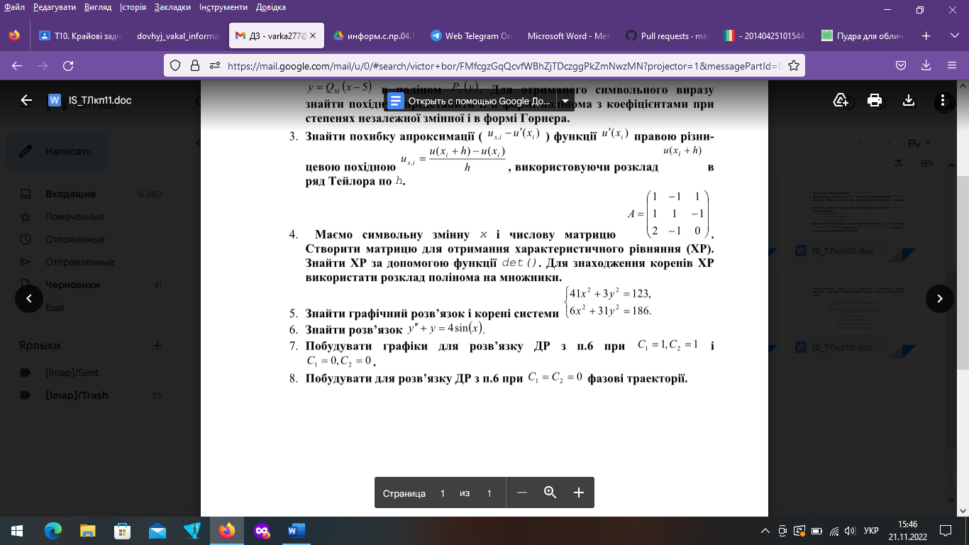
clear
clc
syms x
A = [1 -1 1; 1 1 -1; 2 -1 0];
H = [-x, 0, 0; 0, -x, 0; 0, 0, -x];
K=A.*H;
W=det(A)
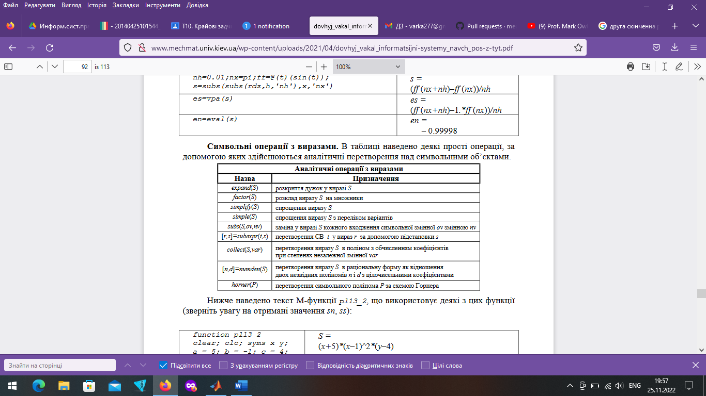

%% pl13_9.m
clear all, close all, clc
ezplot('41*x^2+3*y^2-123’,[-2,2]), hold on
ezplot('6*x^2+31*y^2-186',[-2,2]), grid on
S = solve('41*x^2+3*y^2-123=0',...
'6*x^2+31*y^2-186=0', 'x', 'y');
s = strcat(s1,' б)\n',s2);
fprintf(s);
n = length(S.x);
for k = 1 : n
fprintf('%17.8f |%17.8f\n', double(S.x(k)), double(S.y(k)));
end
pause, clear all, close all



function my_1
syms x
z = dsolve('x(t)','D2y+y=4*sin(x)');
u = subs(subs(z,C1,1),C2,1);
h = subs(subs(z,C1,0),C2,0);
ezplot(u,[-5,5,-5,5]); hold on;
ezplot(h,[-5,5,-5,5]); grid on; pause;
ParametricPlot[Evaluate[xyc[1, 1]], {t, 0, 10}, PlotRange -> All]
ParametricPlot[Evaluate[Table[xyc[1, 0], {0, 1, 10}]], {t, 0, 10},
PlotRange -> All]
ParametricPlot[Evaluate[Table[xyc[0, 1], {0, 1, 10}]], {t, 0, 10},
PlotRange -> All]

